***Stretchable Electronics, Smarter Connectivity***

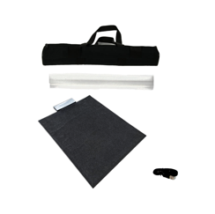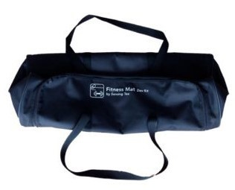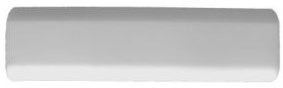

***1.Health Mat 2.Transportation bag 3.Velcro® straps 4.Foam tube 5. USB cable***

**Install the Health Mat Install the Demo Software**

**1. Remove the content** from the transportation bag (element 2). **Recommended Requirements:** Intel Core® i5, Windows® 10, 4 GB **2. Remove the Velcro straps (element 3) and unroll the mat** RAM, USB, Bluetooth® connectivity. Using a system with lower fea-

**(Element 1)**. tures can cause a malfunction of the software.

1. **Place the Health Mat** on a flat surface.
2. **Charge the mat using** the USB cable (element 5) provided and a **1. Install the Demo Software as an Administrator to use all the** compatible USB transformer in your country for at least 2 hours. **features of the system.** You can find the installation file in the **5. Switch on the mat** using the switch located on the side of the case. Dropbox® folder we provided in an email after your purchase.

The white LED on the front of the case will start blinking.

**2. Connect the Floor Mat to your computer.**

**a. Via Bluetooth:**

i. Go to the Bluetooth settings in your computer or device and pair your electronic unit. The requested password is 1234. The Health Mat and your computer must be at no more than 5 m to ensure proper connection. ii. Identify the COM assigned to your electronic unit. To do so go to Control Panel > Hardware and Sound > Devices and

Printers. Locate the unit, right click and go to “Properties”. In the properties window, choose the “Hardware” tab, place the mouse pointer over the first line available and you will see the COM assigned to your electronic unit. The format is COM##, where ## is a number. iii. Run the software and choose your Development Kit in the initial screen of the program. iv. In the software window, select your COM from the dropdown menu at the top-left of the screen and click the “play” icon. Now the Health Mat is successfully connected to your device and the “play” icon will change to a red “stop” icon.

**The Health Mat Development Kit must be used on flat surfaces and installed as instructed. Only store the product using the original packaging. Not following the installation instructions or alterating the Development Kit in any form without prior authorization from Sensing Tex will void the warranty. Please contact our support team at support@sensingtex.com if you have questions or need assistance.**